**Chapter 6 - Molecular Biology**

**All Lectures Uploaded on YouTube:**

[**https://tinyurl.com/fkm9-biology**](https://tinyurl.com/fkm9-biology)

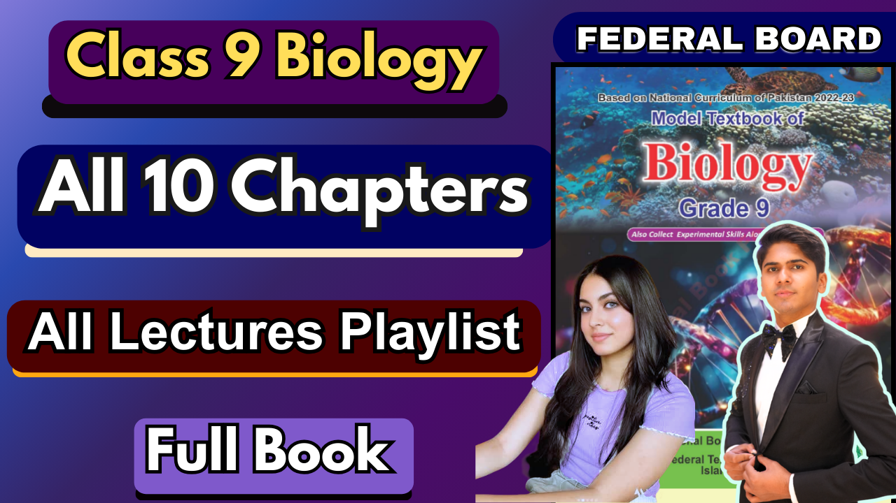

**6.1. Biochemistry/Molecular Biology**

Biochemistry is the study of chemical compounds and processes in living organisms. It helps solve problems faced by organisms using knowledge from biology and chemistry.

* Sometimes biochemistry and molecular biologyare used interchangeably.
* **Molecular biology** specifically focuses on the interaction of biomolecules like DNA during processes like replication, transcription, and translation.

Protoplasm refers to cytoplasm, cell membrane and nucleus.

**6.1.1. Importance Of Biochemistry**

* Biochemistry helps explore cell biology and anatomy and is essential for understanding life processes such as photosynthesis, respiration, digestion, inheritance, and diseases at a biochemical level.

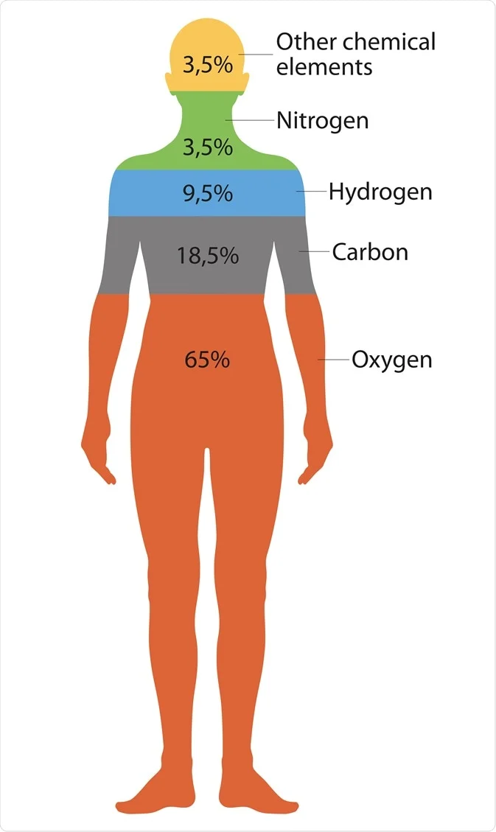

**6.1.2. Bioelements:**

Living organisms are made up of *protoplasm*, which contains bioelements. Of the 92 naturally occurring elements, 16 are considered bioelements, divided into major and minor bioelements.

* **Major bioelements** (99% of protoplasm): Oxygen, Carbon, Hydrogen, Nitrogen, Calcium, Phosphorus.
* **Minor bioelements** (1% of protoplasm): Potassium, Sulphur, Chlorine, Sodium, Magnesium, Iron, Copper, Manganese, Zinc, Iodine.

**6.2. Biological Molecules**

* Molecules used in metabolic processes (catabolism and anabolism) are called biological molecules. They include both **organic** molecules (carbohydrates, proteins, lipids, and nucleic acids) and **inorganic** molecules (water, salts).
* Biomolecules perform a variety of *functions*, such as contributing to growth, reproduction, and energy production.

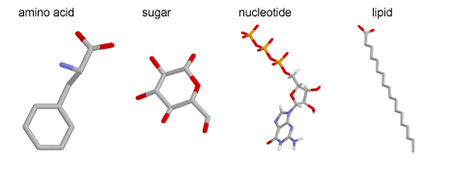

1. ***Carbohydrates***: They are found in cell walls, membranes, SER, and Golgi bodies. Functions as food, energy sources, and components of plant and fungal cell walls. Examples: glucose, lactose, starch, and cellulose.
2. ***Proteins:*** Found in cytoplasm, rough endoplasmic reticulum and Golgi bodies. They are the main source of energy in the body and form the components of cell membranes and chromosomes. Examples: haemoglobin, hormones, enzymes and antibodies
3. ***Lipids:*** are found in the cell membrane and smooth endoplasmic reticulum. They are responsible for providing cells with long-term energy and forming parts of the cell membrane. Examples include fats, phospholipids, oils, etc.
4. ***DNA:*** it is found in the nucleus- especially chromosomes. Play the main role in storing and passing genetic information
5. ***RNA:*** they are usually found in the nucleolus and cytoplasm and are the key tools for protein synthesis and translation.

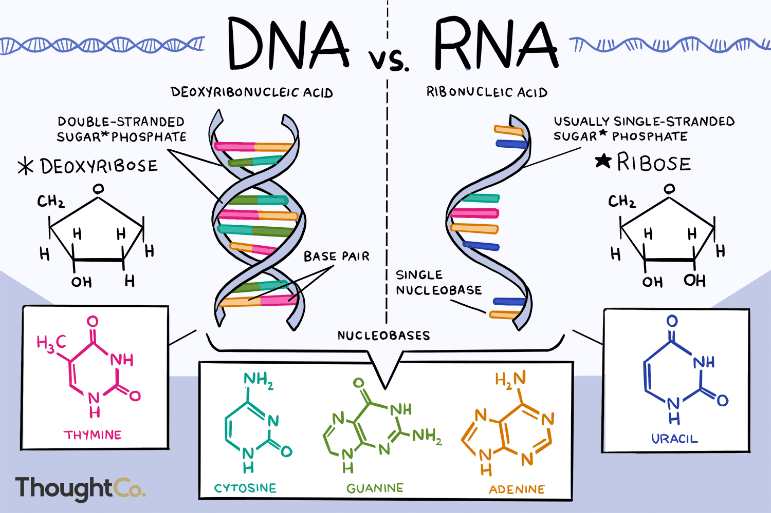

**6.3. Proteins**

* Proteins are formed in ribosomes and are the main functional components of the cell, constituting about 55% of a cell’s mass.

**6.3.1. Chemical Composition Of Proteins**

* Proteins are mainly composed of carbon (C), hydrogen (H), oxygen (O), nitrogen (N), and sometimes sulfur (S) and iron (Fe). They are made of polypeptides, which are chains of amino acids.
* Polypeptide- multiple chains of amino acids joined by peptide bond
* Identification of amino acid structure can be done through N (nitrogen atom)

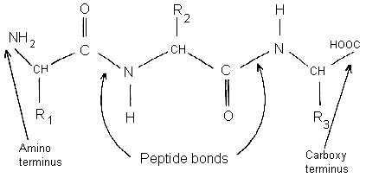

**6.3.2. Amino Acids**

* Amino acids are the building blocks of proteins. There are 20-25 different types of amino acids commonly found in proteins.
* Each amino acid contains an alpha-carbon (α) attached to a hydrogen atom, an amino group (-NH2), a carboxyl group (-COOH), and an R-group that varies for each amino acid.

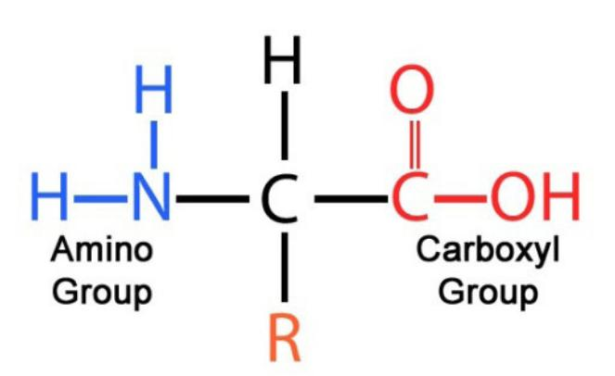

**6.3.3. Structure Of Proteins**

* The structure of a protein may consist of a single polypeptide or multiple polypeptides. The bond between amino acids in a chain is called a **peptide** bond.
* **Primary Structure:** The linear chain of amino acids in a specific sequence.
* **Secondary Structure:** The folding of the polypeptide chain due to additional bonds.
* **Tertiary Structure:** The further folding of the secondary structure into a more complex shape due to even more bonds.
* **Quaternary structure:** when two or more tertiary structures of polypeptide chains bond with each other

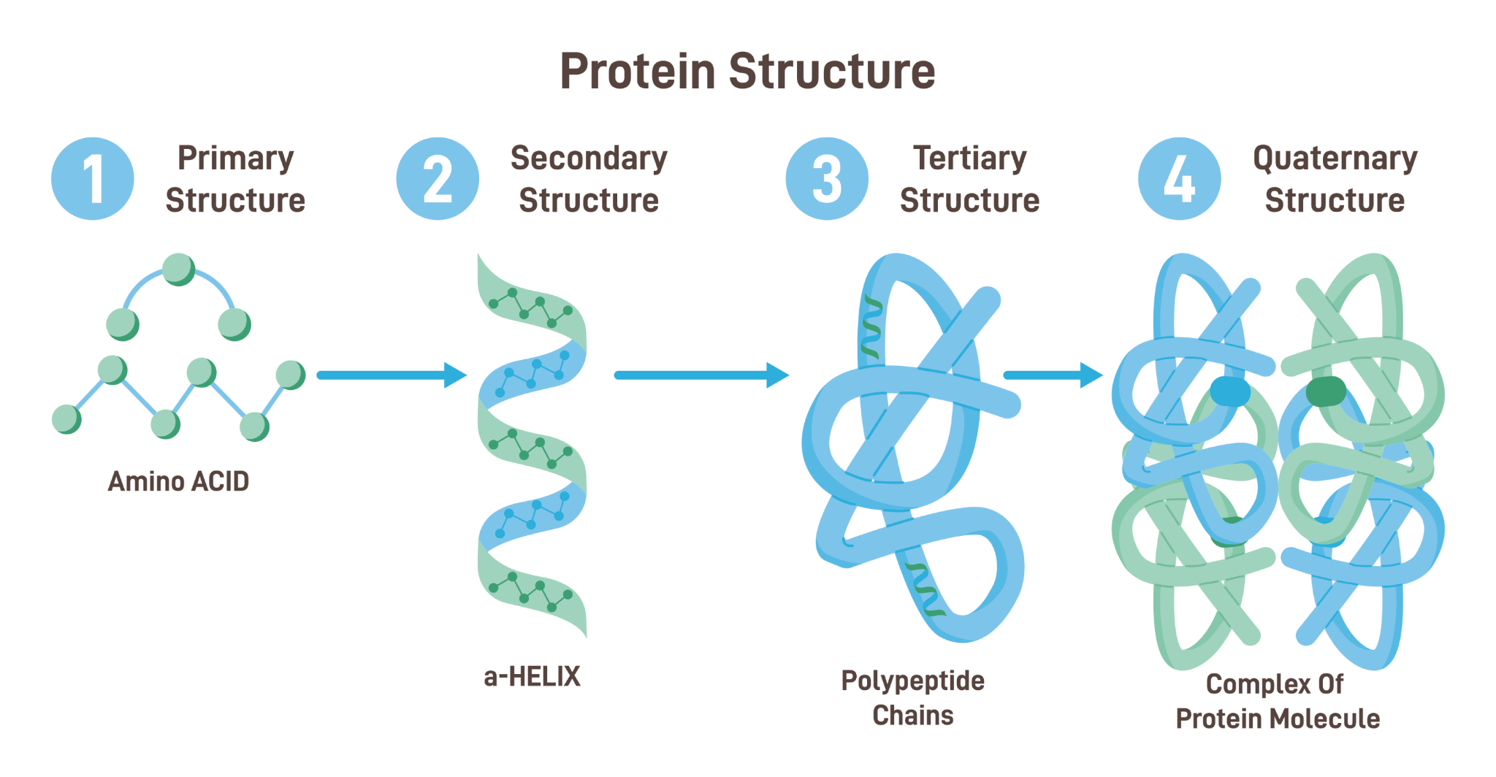

2 **shapes** of proteins:

1. **Fibrous:** long, strand-like structures, usually in the secondary protein structure. They provide structural support and strength. E.g., collagen and keratin
2. **Globular:** Compact, spherical or globular shape, found in complex tertiary or quaternary structures. They perform various versatile functions like enzymes. E.g., enzymes and haemoglobin

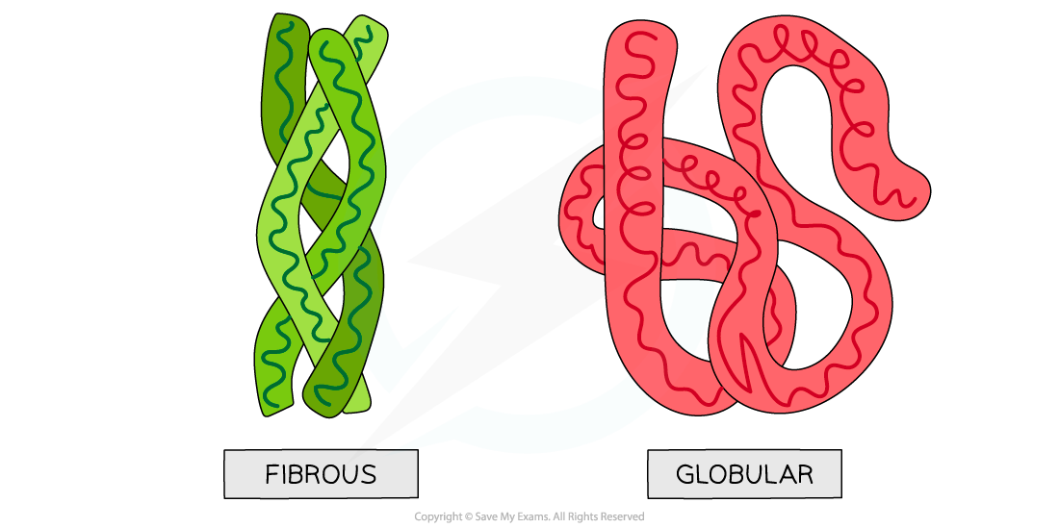

**6.3.4. Functions Of Proteins**

* Proteins are critical for cellular functions. Each protein has a specific function depending on its structure.
* One gram of protein can perform various roles in forming structures and conducting chemical reactions in the body.
* ***Examples:***

1. Cell membrane proteins; channel and carrier proteins which aid in transferring materials in and out of the cell and antigens at the cell surface to mark toxic materials.
2. Enzymes; control biochemical reactions (starch converted to glucose)
3. Hormones; are chemical messengers for regulating different bodily functions, e.g., insulin release.
4. Antibodies; provide immunity against germs
5. Haemoglobin; is involved in the transport of oxygen and carbon dioxide
6. Fibrinogen; blood clotting to stop bleeding
7. Actin and myosin; aid in muscle contraction and relaxation
8. Collagen provides strength and support to skin, bones and muscles. Keeps the tissues strong and flexible
9. Keratin; a component of hair, nails, horns and beaks to protect them from damage
10. Histone; attached with DNA to form chromosome

**6.3.5. Sources Of Proteins:**

* There are two main sources of proteins- plants and animals.
* The most common plant sources are *beans, lentils, peas and nuts.*
* Animal sources include *milk, beef, mutton, egg, fish and seafood.*
* Animal-based proteins have a higher concentration of protein per gram and are easier to digest due to low fibre content. However, it is high in saturated fats and cholesterol.
* Plant-based proteins are rich in fibre but lower in saturated fats and cholesterol levels. The per gram concentration of proteins is also slightly lower in this than animal-based proteins.

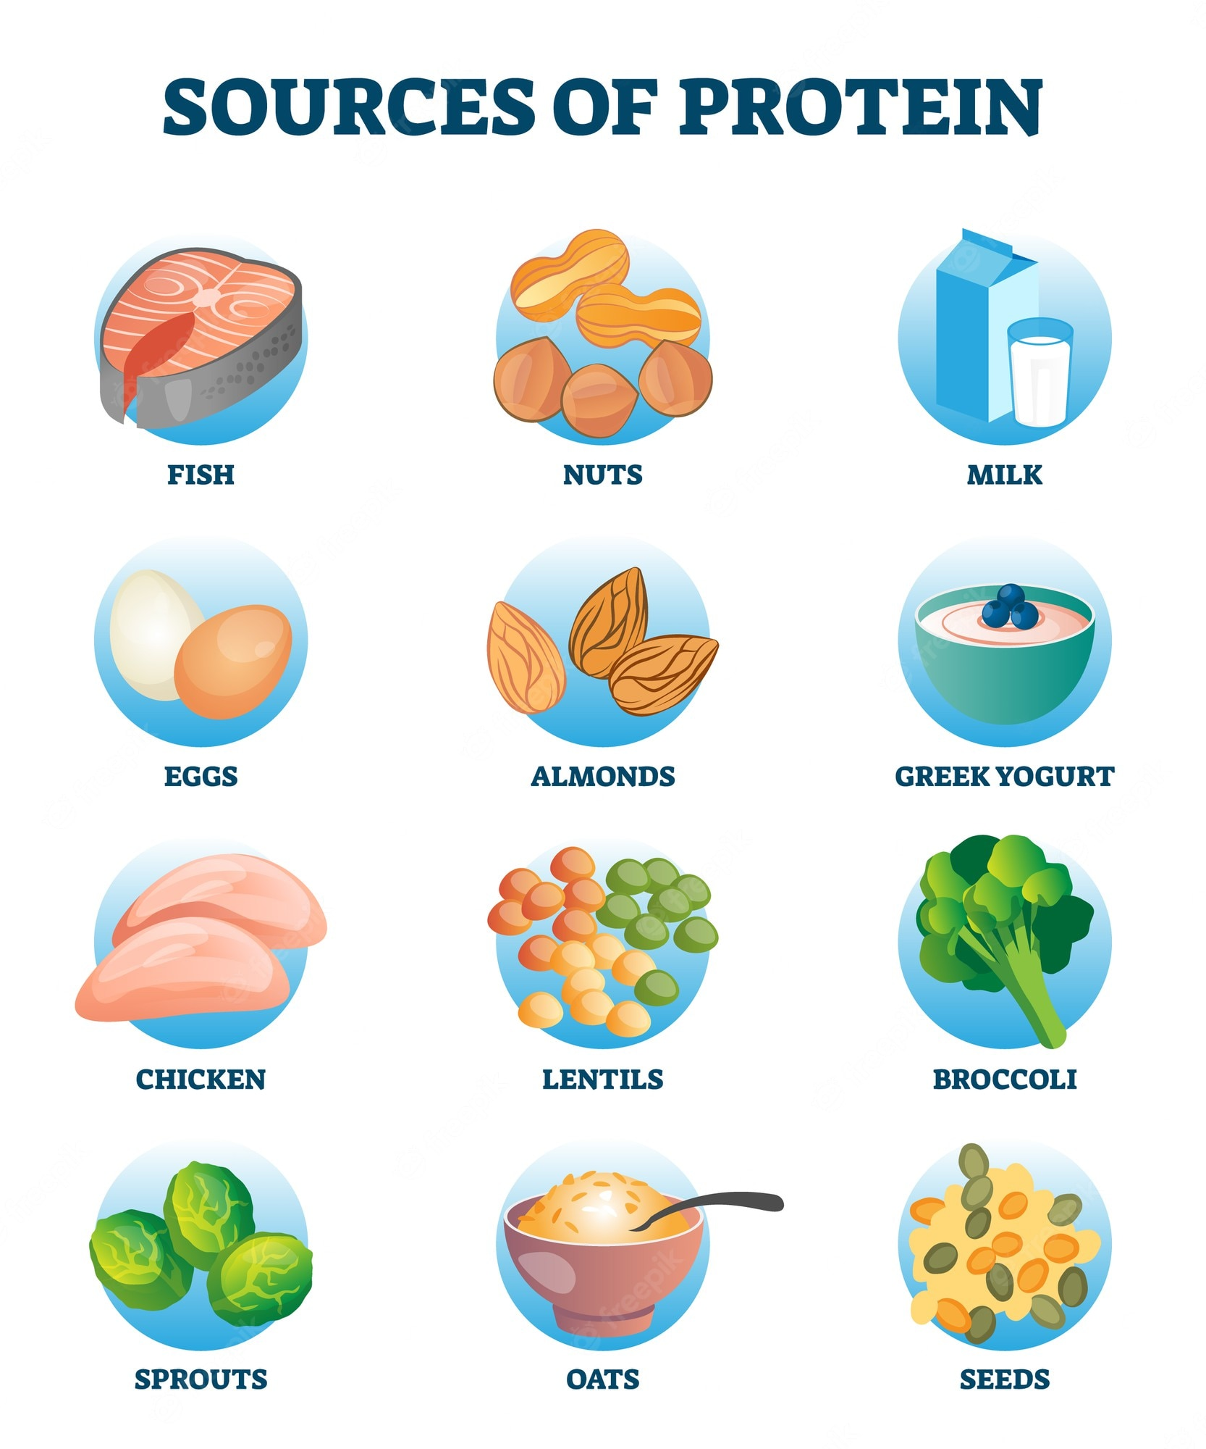

**6.4. Lipids**

* They are organic compounds which are found in living organisms in the forms of oils, waxes, fats and steroids.
* They are hydrophobic, so insoluble in water but dissolve in organic solvents like alcohol.
* Provide energy and structural support
* One gram of lipids contains double the amount of energy than carbohydrates due to a more carbon-hydrogen bonds ratio.

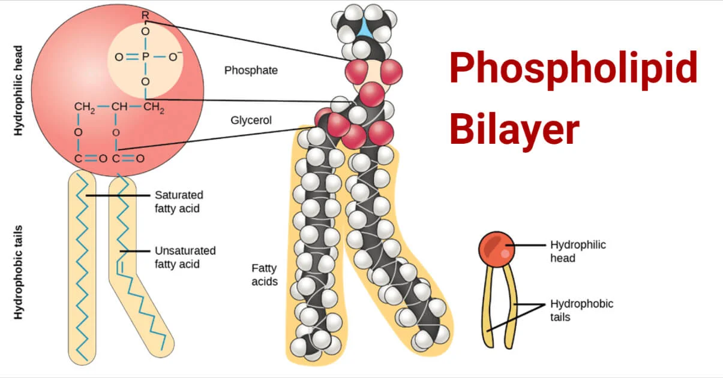

**6.4.1. Structure Of Lipids:**

* Lipids are chemically composed of Carbon (c), Hydrogen (H) and Oxygen (O)
* The two main structural components are glycerol (alcohol part) and fatty acids
* Fatty acids are also of two types; saturated and unsaturated.
* **Saturated fatty acids:** Contain single carbon-carbon bonds, solid at room temperature (e.g., butter, ghee)
* **Unsaturated fatty acids:** Contain one or more double or triple bonds, liquid at room temperature (e.g., olive oil, soybean oil).
* Fats are saturated and oils are unsaturated
* Triglycerides are formed by the combination of one glycerol molecule and three fatty acids joined through **ester** bonds. Also called Tri-Acyl glyceride

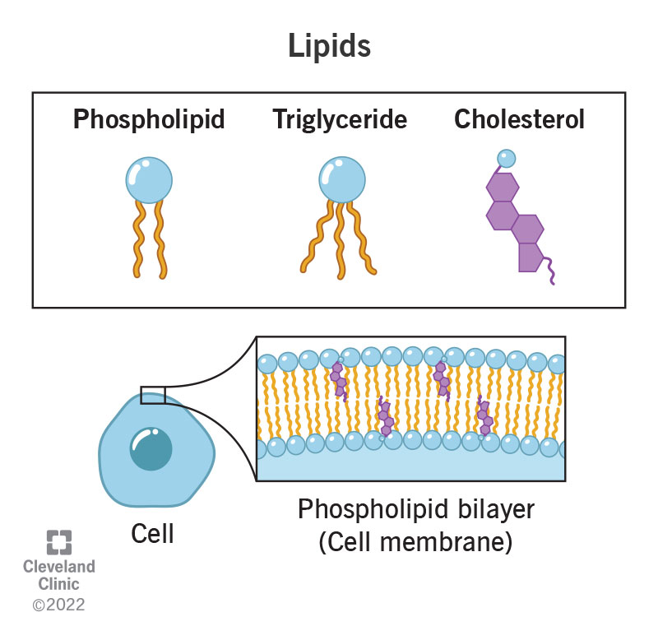

* Some complex lipids contain additional groups like phosphate and nitrogen bases (e.g., phospholipids, waxes).
* Some lipids lack fatty acids in the formula, and rather have three-ring structures; examples include steroids (cholesterol) and vitamins (e.g., Vitamin D). They are called Derived lipids.

**6.4.2. Functions Of Lipids:**

* Lipids have multiple critical roles in organisms, including structural, metabolic, and protective functions

1. Phospholipids and cholesterol form the main structure of cell membranes, maintaining their fluidity and integrity.
2. Lipids are a dense energy source, providing 9.1 kcal/g (compared to 4 kcal/g from carbohydrates). Stored in fat cells, liver and blood as triglycerides, which can be metabolized when energy is required.
3. Lipids like steroids (e.g., cortisol, testosterone) function as hormones to regulate physiological processes.
4. Some fat deposits in mammals act as insulators, preventing heat loss in cold environments.
5. Insects use wax to construct their hives
6. Waterproof layer in plants (waxy cuticle) prevents water loss
7. Lipids also assist in the absorption of fat-soluble vitamins (A, D, E, K).
8. Lipids cushion and protect internal organs (e.g., kidneys, heart) against mechanical shocks.

#### **6.4.3. Sources Of Lipids**

1. **Animal Sources: (saturated fats)**

* Butter, ghee, cream, fish liver oil, meat, and eggs. These are rich in saturated fats and cholesterol.

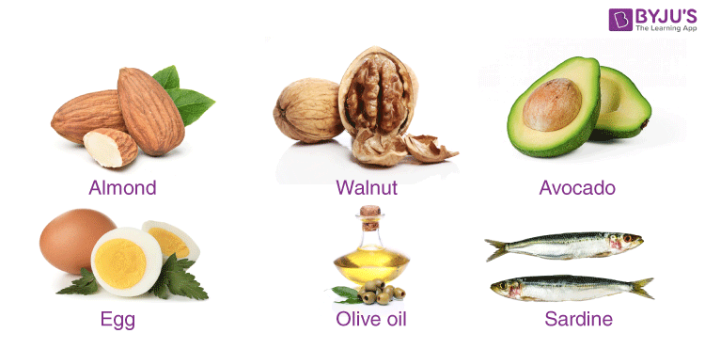

1. **Plant Sources: (unsaturated fats)**

* Mustard oil, olive oil, sunflower oil, soybeans, avocados, and nuts. These are rich in unsaturated fats and essential fatty acids.

**6.5. Carbohydrates:**

* Carbohydrates, also known as saccharides (sugars), are the primary energy source for most organisms.
* The simplest form of carbohydrates is glucose which is formed by plants through photosynthesis.
* This glucose is used to form complex forms of carbohydrates like starch and cellulose.

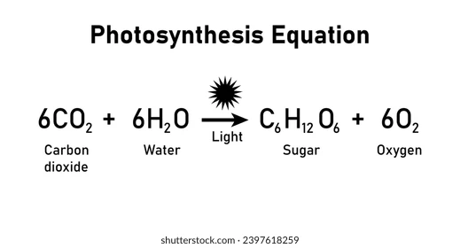

**6.5.1. Structure Of Carbohydrates:**

* They consist of carbon (C), hydrogen (H), and oxygen (O), usually in a ratio of 1:2:1.
* The formula of glucose is C6H12O6
* The number of carbon atoms is equal to the number of water molecules in carbohydrates.
* Therefore, Cx(H2O)y is the general formula which works for all types of carbohydrate molecules and types.

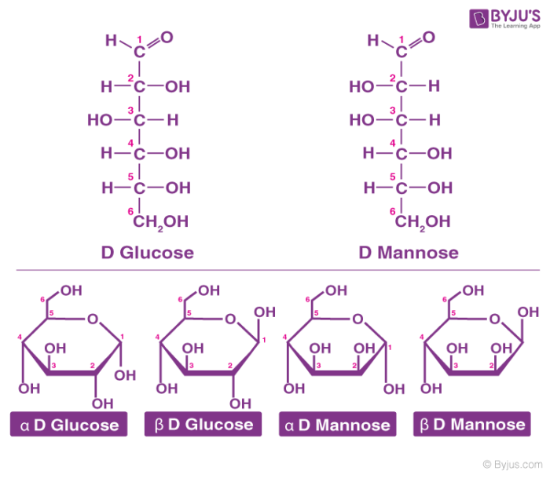

**6.5.2. Functions Of Carbohydrates:**

* Provide a quick and primary energy source, yielding 4 kcal/g.
* Starch (plants) and glycogen (animals) serve as energy reserves.
* Dietary fibres (e.g., cellulose) promote digestive health and avoid constipation
* Cellulose provides structural support to plant cell walls. Chitin forms the exoskeleton of arthropods and fungal cell walls.
* Sucrose and other sugars are used as natural sweeteners in food.

#### **6.5.3. Sources Of Carbohydrates**

1. **Plant Sources:**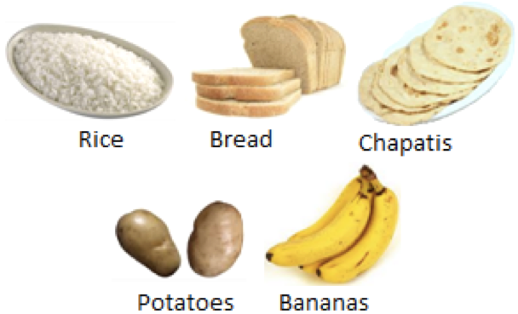

* **Monosaccharides:** Fruits like apples, bananas, and grapes.
* **Polysaccharides:** Cereals (wheat, rice, maize), legumes, potatoes, and vegetables.

1. **Animal Sources:**

* Milk and dairy products (lactose).

**6.6. Classification Of Carbohydrates:**

**6.6.1. Monosaccharides;**

* The simplest form of carbohydrates, so are not further broken down or hydrolysed
* They are produced during photosynthesis (glucose)
* White crystalline solids at room temperature
* Soluble in water and sweet in taste
* They vary based on the number of carbon atoms present in their structures. E.g., trisoses (3C), pentoses (5C)
* In crystal form, the structure is chain-like, while in solution, they take up a ring structure.
* Example formula: **C₆H₁₂O₆**

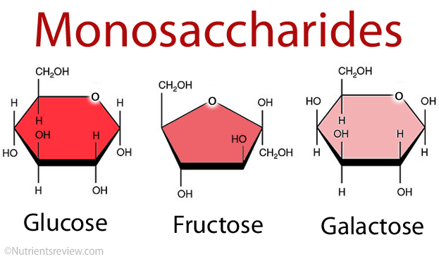

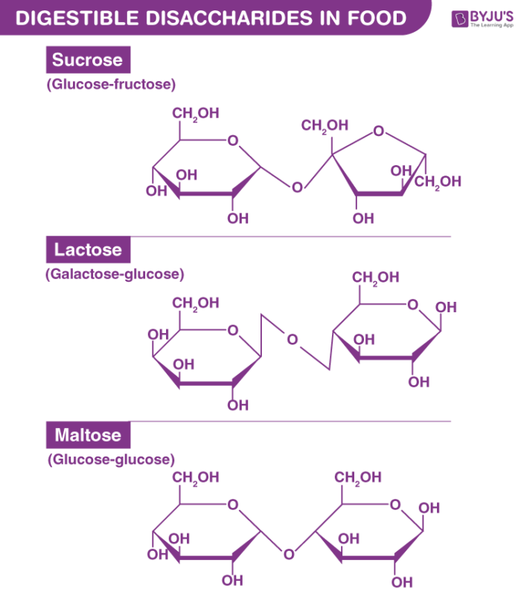

**6.6.2. Disaccharides**

* A simple form of carbohydrate which is formed through the condensation of two monosaccharides
* White crystalline solids but less soluble and less sweet than monosaccharides.
* General formula: **C₁₂H₂₂O₁₁**

**Polysaccharides**

* They are polymers of more than ten monosaccharides that form complex carbohydrates.
* They are usually tasteless or mildly sweet
* Formed in cells of plants and animals for storage purposes, e.g., starch in plants and glycogen in animals.
* The hydrolysis (breakdown) of one polysaccharide results in large units of energy.

Hydrolysis- breakdown of molecules using water

Condensation- building up of larger molecules with the release of water

**6.7. Nucleic Acids**

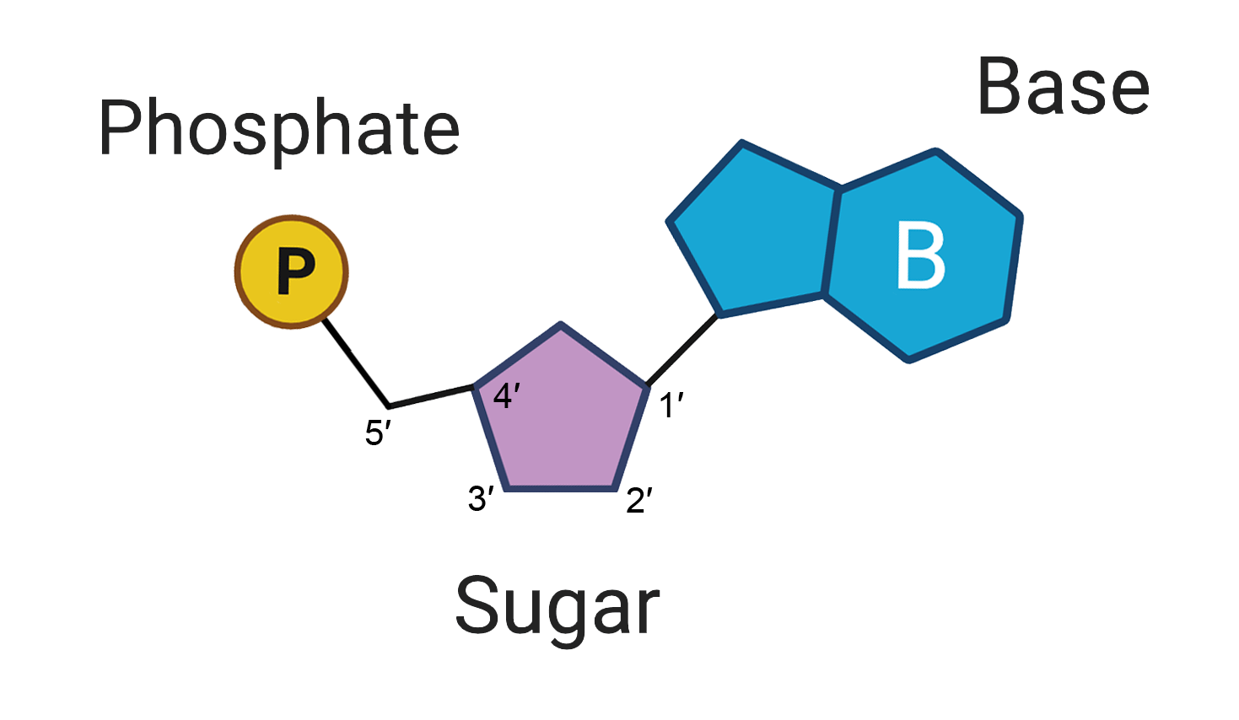

**Nucleic Acids:**

* It is a kind of biomolecule which stores and transfers hereditary information across generations.
* Two main types include DNA (Deoxyribonucleic acid) and RNA (Ribonucleic acid), which are both made of **nucleotides**

**6.7.1. Structure Of Nucleotide:**

1. *Pentose sugar*; 5 Carbon sugar. In the case of DNA and RNA, its **Deoxyribose** and **Ribose**
2. *Nitrogen base;* a ring structure attached to the first carbon atom. Two main types of nitrogen bases, **Purines** (double ring) and **Pyrimidines** (single ring)
3. *The phosphate group;* is the acid part of nucleic acid, which is attached to the fifth carbon atom. It links nucleotides to each other through a **‘phosphodiester bond’**

**Nitrogen bases:**

1. Pyrimidine (single ring)
2. Uracil– RNA only
3. Thymine— DNA only
4. Cytosine— found in all types
5. Purine (double ring)
6. Adenine
7. Guanine

* Nitrogen bases determine the coding properties of nucleic acid. The bases determine the sequence of genetic information, specific to proteins and their properties.

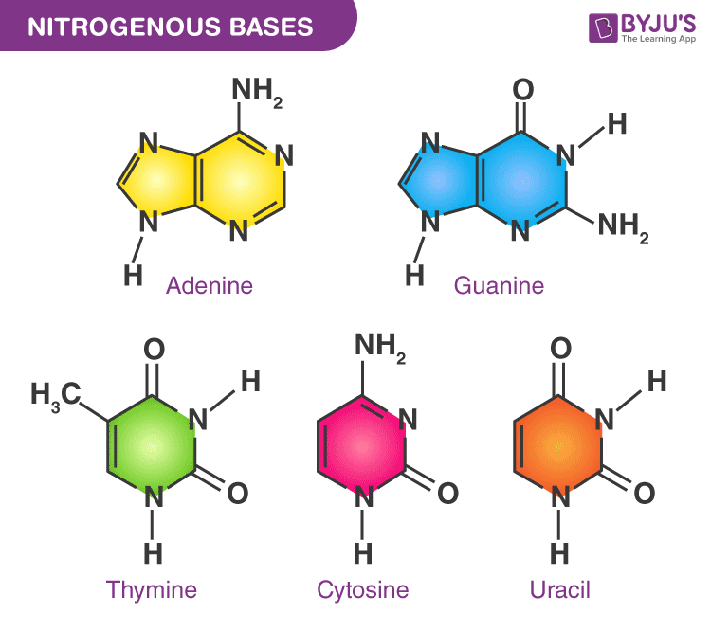

* In DNA, both purines are present and in pyrimidines, Thymine and Cytosine are present
* While in RNA, instead of Thymine, Uracil is present

**6.7.2. Structure Of DNA:**

* DNA is a polynucleotide, made up of many deoxyribonucleotides
* Double-stranded structure arranged like a ladder, with both strands coiling around like a helix
* Both opposite strands are anti-parallel

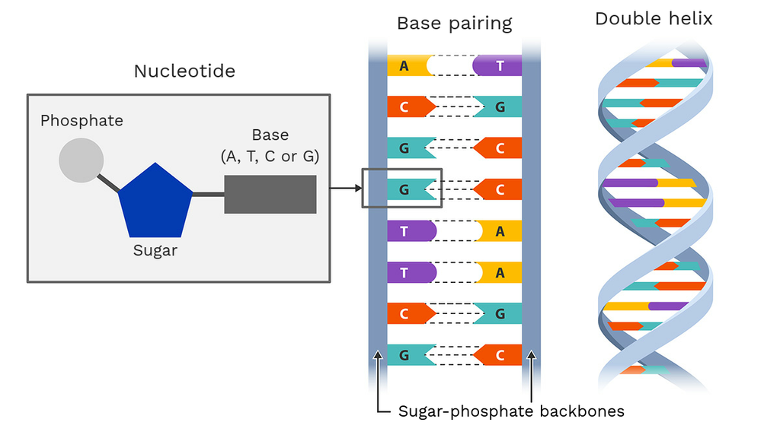

* The outer structure is formed of a sugar-phosphate backbone, with phosphate sugar of one nucleotide binding to the carbon atom of the other nucleotide.
* Base pairing formed between adenine and thymine and cytosine and guanine, which are always present in equal amounts
* This pairing is highly specific and the sequence of nucleotides in one strand is complementary to the other strand
* Both strands are held through weak hydrogen bonds
* **Two bonds** between adenine and thymine while **three bonds** between guanine and cytosine
* The overall diameter of double helix DNA is 2 nm

**6.8. The Function Of DNA As A Carrier Of Hereditary Information**

* Heredity is the transmission of traits and genetic characteristics from one generation to the next
* Offsprings and parents may differ in appearance but share similar genetic characteristics.
* Each generation transfers **hereditary instructions** to the next, ensuring continuity of life.
* Found in the nucleus in the form of chromatin

**6.8.1. Units Of Heredity: Genes:**

* In a **non-dividing cell**, hereditary material (DNA) exists as chromatin (DNA + histone proteins).
* Chromatin fibres coil into chromosomes during cell division.
* Genes are small segments of DNA located on chromosomes.
* They store and control the hereditary information
* **Genome**: The entire set of genetic material. Total number of genes in the complete set of chromosomes of an organism.

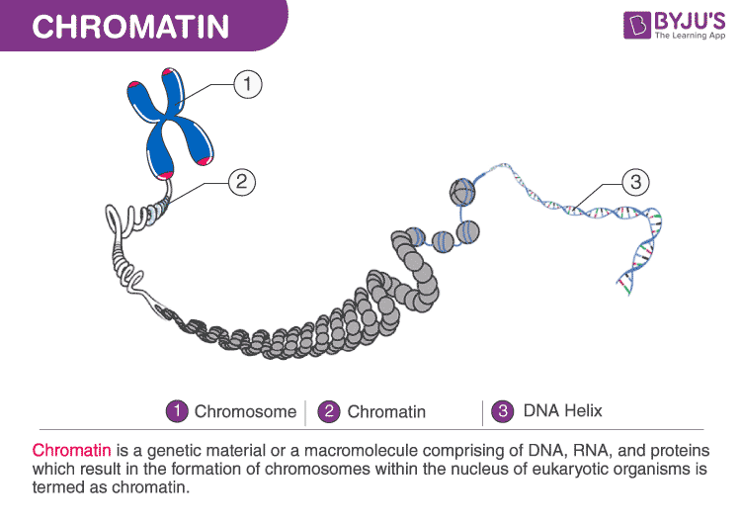

**6.8.2. Gametes As Vehicles For The Transfer Of Information:**

* Gametes (sperm and egg) carry chromosomes (sets of genes) from parents to offspring.
* Fertilization: The fusion of male and female gametes forms a **zygote**, transferring parental genetic material to the next generation.
* Genes on chromosomes carry hereditary information.

**6.9. Structure Of RNA**

* RNA is a polynucleotide chain similar to DNA but is single-stranded.
* Contains **ribose sugar** instead of deoxyribose.
* Has **uracil** instead of thymine.
* RNA nucleotides are not bonded to complementary bases like in DNA.
* RNA is synthesized from DNA through **transcription**.

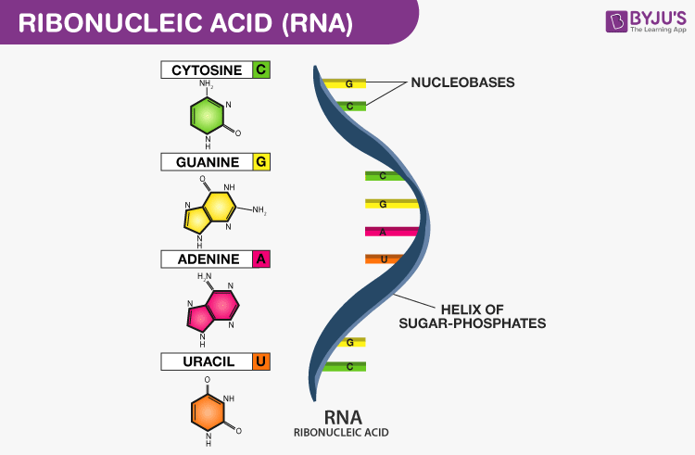

**6.10. The Function Of RNA**

* After being synthesized in the nucleus, RNA is transported to the cytoplasm.
* RNA plays an intermediate role in controlling heredity by directing protein synthesis (translation).
* **Types of RNA:**

1. mRNA (messenger RNA); carries messages or the genetic information of DNA from the nucleus to the cytoplasm
2. tRNA (transfer RNA); transfers amino acids to ribosomes during protein synthesis
3. rRNA (ribosomal RNA); Forms structural and functional components of ribosomes.

**6.11. Flow Of Genetic Information**

* Genes contain instructions for protein synthesis
* The flow of biological information from DNA to RNA and then to proteins
* This flow is called the Central Dogma of Life
* Proteins are the structural and functional molecules of living organisms whose primary structure is determined by DNA
* The two main steps involved in **gene expression** are:

**6.11.1. Transcription:**

* The DNA sequence is copied into the mRNA
* Both DNA strands of a gene unwind; only one strand (**coding strand**) is transcribed.
* After transcription (copying to mRNA), DNA strands coil back to their original double-helix form.
* Takes place in the **nucleus**

**6.11.2. Translation:**

* mRNA moves to ribosomes in the **cytoplasm**.
* Ribosomes read mRNA codons and link specific amino acids (delivered by tRNA) to form a polypeptide chain.
* This sequence determines the final protein structure.

